**Kleur per games**



geel: #FFFF0B

zwart: #FFFF0B

**Gun Godz**

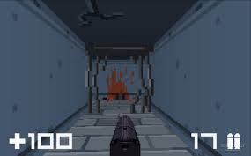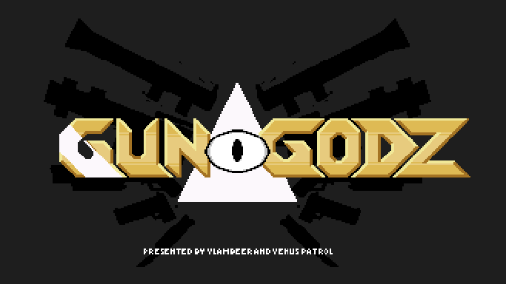

**Kleur:**

**Geel/oranje: #E0C16Bx**

**Geweer: #E0C16B**

**Wit: #FBF6FB**

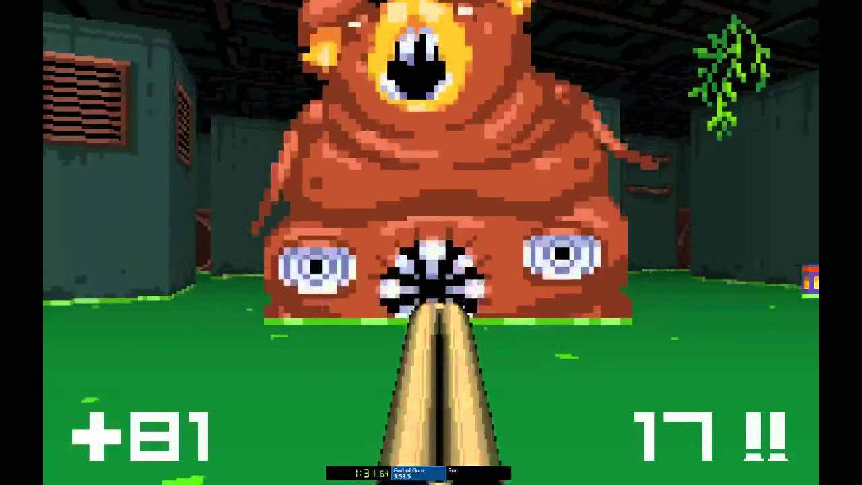

**Luftrausers**



**rood: #7A353F**

**bruin: #AD806A**

**beige: #E9D89F**

**Nuclear Throne**

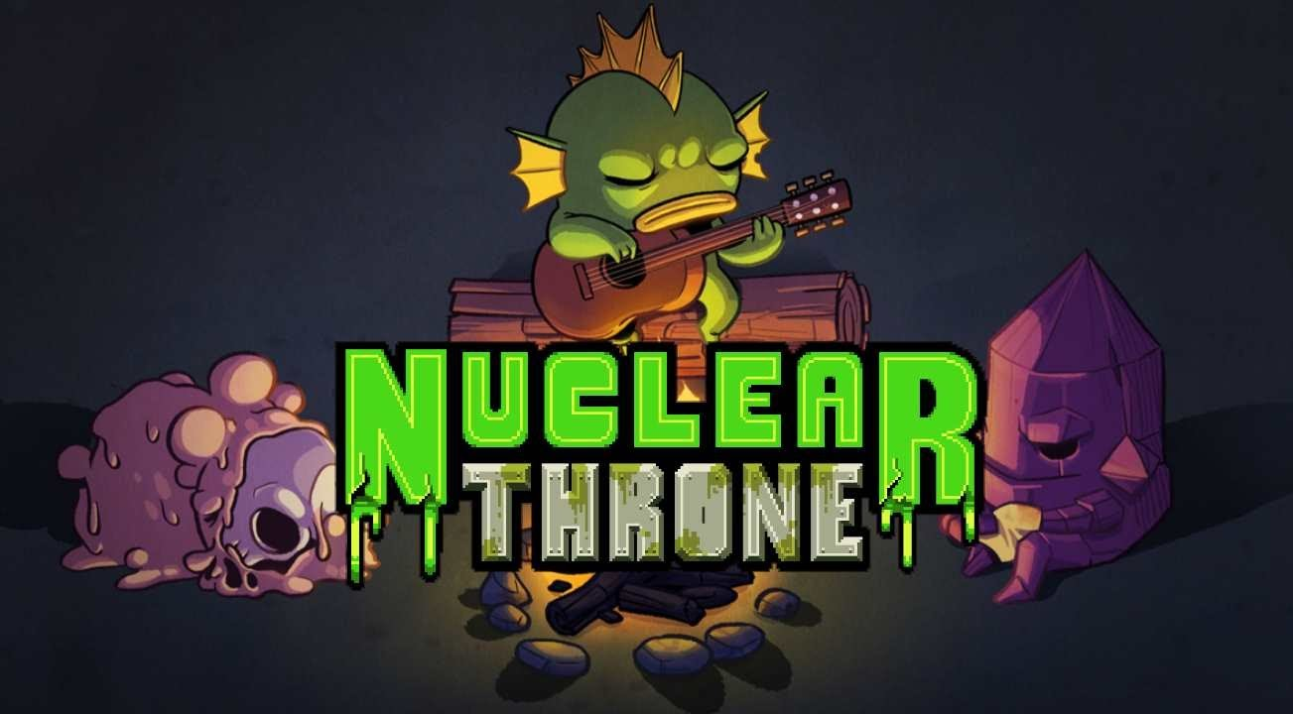

**Ridiculous Fishing**

**Groen: #44D215**

**Donker-groen: #334229**

**Grijs: #949A7D**

**Paars: #663E6C**

**Bruin(gitaar): #5F2323**

**Geel: #F7C322**

**Serious Sam: The Random Encounter**

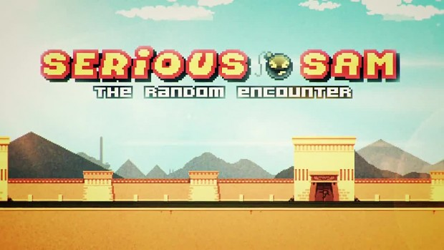

**Rood: #D50B1F**

**Geel: #D50B1F**

**Groen:** **#9D9846**

**Wit:** **#EEFFE0**

**Zwart: #21190C**

**Oranje:** **#E5AD51**

**Super Crate Box**

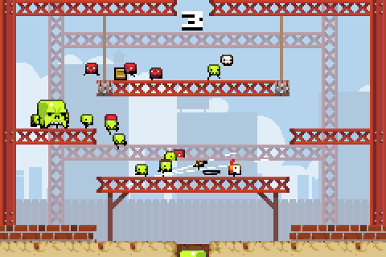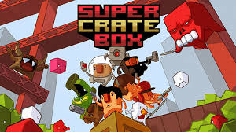

**rood: #C23025**

**bruin: #CEBE5A**